**SRS**

**A BASIC**

**SRS DOCUMENT**

**ON**

**text line segmentation for medieval manuscripts**

CSE-3E | Team-84

**Table of Contents**

1. Introduction3-5

1.1 Purpose3-5

1.2 Intended Audience4

1.3 Intended Use4

1.4 Scope5

1.5 Definitions & Acronyms5

2. Overall Description6-8

2.1 User Needs7

2.2 Assumptions8

2.3 Dependencies8

3. Requirement Specification9-10

3.1 Functional Requirements9

3.1.1 Image loading 9

3.1.2 preprocessing9

3.1.3 seam carving algorithm9

3.1.4 text line segmentation 9

3.2 Non-Functional Requirements10

3.2.1 Robustness 10

3.2.2 Accuracy 10

3.2.3 Maintainability10

3.2.4 Supportability 10

3.2.5 Security10

**4. System Features**11

4.1 Hardware Requirements11

4.2 Software Requirements11

**6. Plug-Point App**12

**7. References**13

**1. INTRODUCTION**

* Text Line Segmentation is an essential step in the digitalization of medieval manuscripts which uses computer vision and traditional image-processing techniques.
* These manuscripts, rich in the historical and cultural significance, contain hand written text arranges in lines, often with decorations and irregular layouts.
* Traditional segmentation algorithms designed for modern printed text often struggle to handle the complexities variability present in the medieval manuscripts.
* Therefore, the development of specialized and techniques tailored to the specific requirements of medieval manuscripts is necessary.
* This project is to identify and separate individual lines of text, providing a foundation for subsequent analysis and processing.

**1.1 PURPOSE:**

* The purpose of text line segmentation for medieval manuscripts is to make it easier to read and understand these old handwritten documents. By dividing the text into separate lines, we can use computers to recognize and transcribe the words more accurately.
* It also helps researchers study the manuscripts and learn more about the past.
* Additionally, by digitizing the manuscripts, we can preserve them for the future and reduce the need to handle the fragile originals.

**1.2 INTENDED AUDIENCE:**

* Text line segmentation helps people who study old handwritten documents to understand and analyze them better. By dividing the text into separate lines, it becomes easier to read and make sense of the writing.
* This is important for researchers because it allows them to study the documents more efficiently and find specific information more easily.
* It also helps in accurately transcribing and translating the text. By digitizing the manuscripts and making them accessible online, more people can explore and learn from these ancient writings.
* Additionally, it helps preserve the original manuscripts by reducing the need to handle them directly.

**1.3 INTENDED USE:**

* It makes the text easier to read by dividing it into separate lines, so readers can follow along more smoothly.
* It helps in accurately writing down the text from the document, line by line, making sure nothing is missed or misunderstood.
* By breaking the text into lines, it becomes easier to understand the meaning of the words and sentences, making it simpler to interpret the document.
* Digitizing and segmenting the text allows others to access and study the document without needing to handle the original. It also enables collaboration with other researchers or scholars who can offer insights and perspectives.
* By creating digital versions, the original document can be protected from damage caused by frequent handling. This ensures the document is preserved for future generations.

**1.4 SCOPE:**

**The scope of your project involves:**

* Adapting the seam carving algorithm for text line segmentation in medieval manuscripts.
* Enhancing manuscript images and analyzing them to identify text regions.
* Implementing the seam carving algorithm to separate text lines.
* Evaluating and improving the algorithm's accuracy and efficiency.

**1.5 DEFINITIONS & ACRONYMS:**

* **Text line segmentation:** Text line segmentation is the process of separating lines of text in a document or image, enabling accurate analysis, recognition, and extraction of textual information. It involves identifying the boundaries between lines to facilitate tasks like OCR, transcription, and text analysis.
* **Medieval manuscripts:** Text line segmentation is the process of separating lines of text in a document or image, enabling accurate analysis, recognition, and extraction of textual information. It involves identifying the boundaries between lines to facilitate tasks like OCR, transcription, and text analysis.
* **Computer Vision:** Computer vision is a field that deals with teaching computers to understand and interpret visual information from images or videos. It involves developing algorithms and techniques for tasks like object recognition, image analysis, and video understanding.
* **Image processing:** image processing involves using computer algorithms to modify or analyze digital images. It helps improve image quality, extract useful information, or prepare images for specific purposes. It is used in various fields like medicine, security, and computer vision to work with and understand visual data.
* **seam Carving Algorithm:** The seam carving algorithm is a technique used to resize images while keeping the important parts intact. It works by finding and removing or adding paths of pixels in the image that contain less important information. This allows for resizing images without distorting or losing important elements, making it useful for adjusting image sizes while preserving their content.

2. OVERALL DESCRIPTION

* The system begins by loading the images of the medieval manuscripts that need to be processed.
* The loaded images undergo preprocessing steps to enhance their quality and improve readability. This may include noise reduction, contrast adjustment, and other image enhancement techniques.
* An energy map is generated for the preprocessed images, which highlights the importance and saliency of different regions in the image. This map helps in identifying the areas that contain text lines.
* The seam carving algorithm is applied to the energy map, removing or adding seams to separate the text lines from the background. This step ensures the accurate segmentation of the text lines while preserving the important content.
* The segmented text lines are grouped into bins based on their proximity and similarity. This step helps in organizing and managing the segmented lines for further processing and analysis.
* The system employs a polygon manager to refine and adjust the boundaries of the segmented text lines. This step ensures the lines are accurately represented and properly aligned.
* The final output of the system is the segmented text lines, where each line is separated and distinct. The segmented lines can then be used for various purposes such as OCR, transcription, translation, and further analysis of the medieval manuscripts.

**2.1 USER NEEDS:**

* Users need a system that can separate the text lines clearly and improve their legibility, making it easier to read and understand the content of the manuscripts.
* Users require a simple and efficient way to transcribe the text from the manuscripts into a digital format, ensuring accurate representation of the original content.
* Users want the ability to search for specific words or topics within the text lines of the manuscripts, enabling them to find relevant information quickly and navigate through the text effectively.
* Users value the preservation of the delicate original manuscripts. The project should provide accurate digital versions with well-separated text lines, minimizing the need for physical handling.
* Users appreciate a user-friendly system with an intuitive interface, allowing for easy interaction and integration with other tools or systems used for OCR, transcription, translation, or analysis of the text.

**2.2 ASSUMPTIONS:**

* It is assumed that the provided manuscript images are clear and legible, making it easier to extract the text lines accurately.
* The assumption is that the text in the manuscripts follows a somewhat consistent layout, with regular line spacing and alignment, which simplifies the segmentation process.
* The project assumes that the background of the manuscripts has minimal noise, stains, or damage that could potentially interfere with the segmentation process.
* The majority of the text in the manuscripts is expected to be written horizontally, with the project focusing on handling this type of orientation.
* While acknowledging variations in manuscript styles, scripts, and languages, the project may either focus on a specific subset of manuscripts or incorporate techniques to handle a broader range of manuscript types.

**2.3 DEPENDENCIES:**

* The project relies on obtaining clear and legible images of the manuscripts.
* The project depends on using computer vision and image processing libraries to manipulate and analyze the images.
* Sufficient computational power and memory are necessary for efficient processing of large image datasets.

3. REQUIREMENT SPECIFICATION

**3.1 FUNCTIONAL REQUIREMENTS:**

**The functional requirements for the text line segmentation project for medieval manuscripts can include:**

**3.1.1 Image Loading:**

* The system should be able to load and process images of medieval manuscripts for text line segmentation.

**3.1.2 Preprocessing:**

* The system should include preprocessing capabilities to enhance image quality, reduce noise, and improve the legibility of the manuscripts.

**3.1.3 Seam Carving Algorithm:**

* The system should implement the chosen approach, such as the seam carving algorithm to achieve accurate and efficient text line segmentation.

**3.1.4 Text Line Segmentation:**

* The core functionality of the system is to accurately segment the text lines within the manuscripts, separating them from the background or other elements.

**3.2 NON-FUNCTIONAL REQUIREMENTS:**

**Non-functional requirements for the text line segmentation project for medieval manuscripts can include:**

**3.2.1 Robustness:**

* The system should be robust and able to handle variations in manuscript quality, such as faded or damaged text, without compromising the segmentation accuracy.

**3.2.2 Accuracy:**

* The system should achieve a high level of accuracy in segmenting text lines, ensuring minimal errors or misclassifications.

**3.2.3 Maintainability:**

* The system should be designed and implemented in a way that facilitates ease of maintenance and future updates or enhancements.

**3.2.4 Supportability:**

* The code and supporting modules of the system will be well documented and easy to understand. Online User Documentation and Help System Requirements.

**3.2.5 Security:**

* The system should prioritize the security and privacy of the manuscript data, ensuring that sensitive information is protected and only accessible to authorized users.

**4. SYSTEM FEATURES**

* Text line segmentation for medieval manuscripts have both Software and Hardware requirements. They are as follows:

**4.1 Hardware Requirements:**

* Intel core I3 processor
* Good internet connection

**4.2 Software Requirements:**

* **Programming language:** Python
* Google co-lab
* Computer Vision modules

**TEXT LINE SEGMENTATION FOR MEDIEVAL MANUSCRIPTS**

**Input**

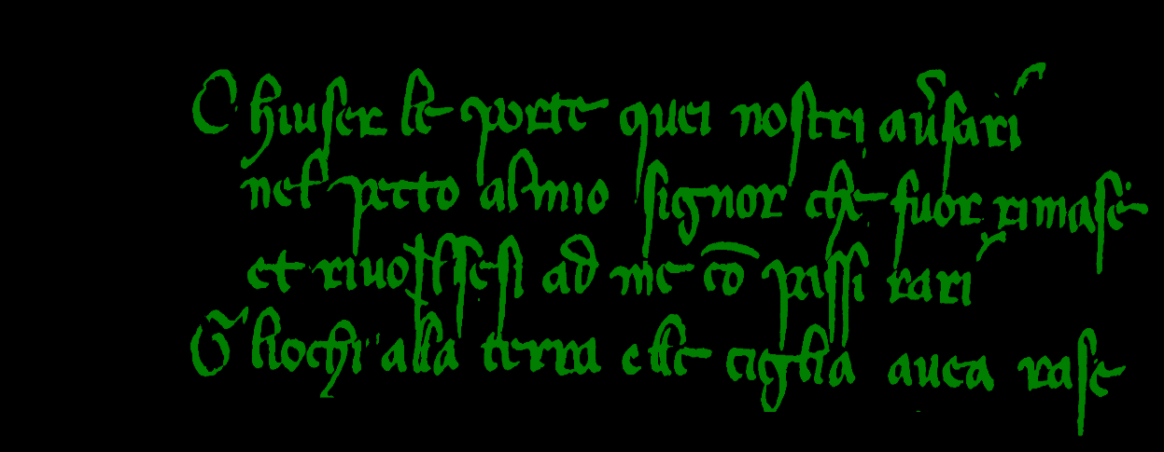

**Output**

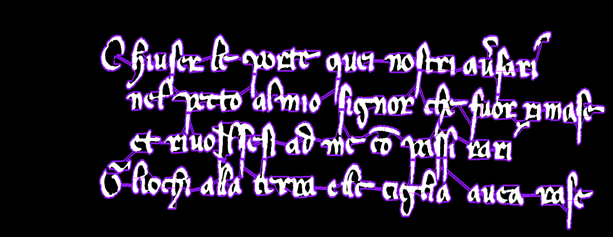

**REFERENCES**

* <https://arxiv.org/abs/1906.11894>

**THANK YOU**